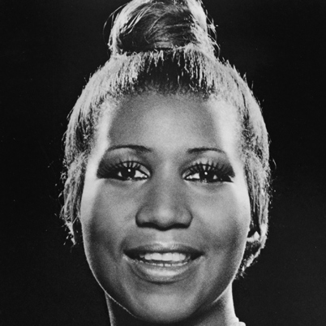**Aretha Franklin: “the queen of soul”**

Aretha Franklin is one of the giants of soul music, and indeed of American pop as a whole. More than any other performer, she epitomized soul at its most gospel-charged. Her astonishing run of late-'60s hits with Atlantic Records--"Respect," "I Never Loved a Man," "Chain of Fools," "Baby I Love You," "I Say a Little Prayer," "Think," "The House That Jack Built," and several others--earned her the title "Lady Soul," which she has worn uncontested ever since. Yet as much of an international institution as she's become, much of her work--outside of her recordings for Atlantic in the late '60s and early '70s--is erratic and only fitfully inspired, making discretion a necessity when collecting her records.

Franklin's roots in gospel ran extremely deep. With her sisters Carolyn and Erma (both of whom would also have recording careers), she sang at the Detroit church of her father, Reverend C.L. Franklin, while growing up in the 1950s. In fact, she made her first recordings as a gospel artist at the age of 14. It has also been reported that Motown was interested in signing Aretha back in the days when it was a tiny start-up. Ultimately, however, Franklin ended up with Columbia, to which she was signed by the renowned talent scout John Hammond.

Franklin would record for Columbia constantly throughout the first half of the '60s, notching occasional R&B hits (and one Top Forty single, "Rock-a-bye Your Baby with a Dixie Melody"), but never truly breaking out as a star. The Columbia period continues to generate considerable controversy among critics, many of whom feel that Aretha's true aspirations were being blunted by pop-oriented material and production. In fact there's a reasonable amount of fine items to be found on the Columbia sides, including the occasional song ("Lee Cross," "Soulville") where she belts out soul with real gusto. It's undeniably true, though, that her work at Columbia was considerably tamer than what was to follow, and suffered in general from a lack of direction and an apparent emphasis on trying to develop her as an all-around entertainer, rather than as an R&B/soul singer