**Review: Beyonce returns to Verizon Center, without much ‘Beyonce’**

BY LAVANYA RAMANATHAN

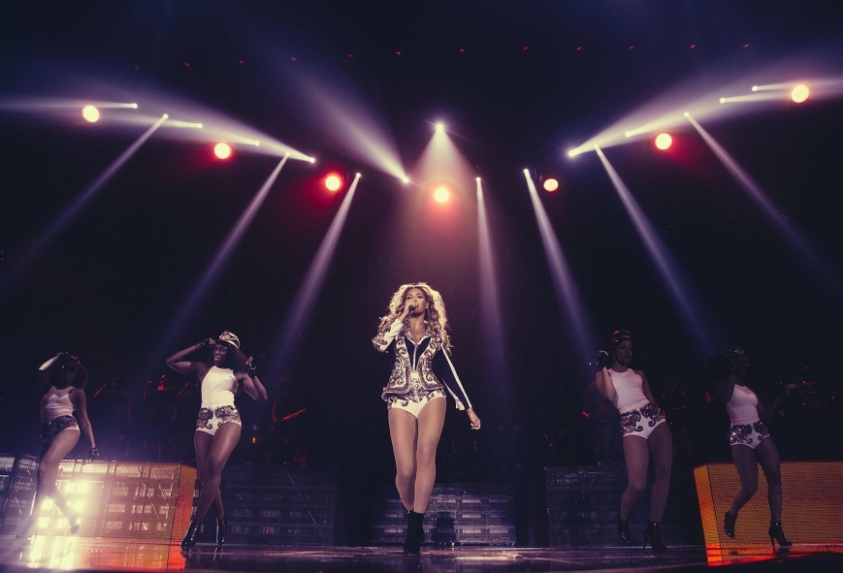

**December 19 at 9:00 am**

Less than a week after she pulled a fast one on the music business and [released a surprise album in the dead of night](http://www.washingtonpost.com/entertainment/music/surprise-beyonce-has-a-new-album-bigger-surprise--its-great/2013/12/13/34e08b1e-6402-11e3-a373-0f9f2d1c2b61_story.html), newly minted maverick Beyonce returned to her regularly scheduled program, strutting across the Verizon Center stage Wednesday night as if, well, nothing much had happened.

Beyonce performs onstage at her "Mrs. Carter Show World Tour" on Wednesday at the Verizon Center in Washington. (Photo by Robin Harper/Invision for Parkwood Entertainment/AP Images)

It was the third time this year that Mrs. Carter had performed her "Mrs. Carter Show" tour to a sold-out crowd of Washington fans, and it was the third time she would begin by sauntering to the middle of her "Bey Stage" and surveying the crowd with put-on awe before launching into "Run the World (Girls)."

Wednesday night, it was impossible not to see the song's refrain -- "Who run the world? Girls" --  as a reference to the game-changing success of "Beyonce," the 14-song, 17-video album/film/immersive experience she released exclusively on iTunes last week. According to [Billboard](http://www.billboard.com/articles/news/5839818/beyonce-breaks-us-itunes-sales-record-sells-617000-in-three-days), the album moved nearly 900,000 digital copies in its first long weekend on the service, but what should have you believing that Beyonce is music's new despot was the requirement that early buyers take the album in full, for $15.99 a pop, rather than pick and choose from among its singles.

But Beyonce played coy about the triumph for most of the night, offering just one song from the album in her 100-minute set. Even her hair, shorn into an edgy bob in the videos that accompany "Beyonce," had been returned, by the grace of God and extensions, to its previous flowing, "Mrs. Carter Show" form.

Was it Groundhog Day? If she and her cheeky menagerie of dancers hadn't been so watchable, it might have been maddening.

The singer, mother and wife seemed to beam her way through an eclectic hit list from her 15-year recording career, offering "Baby Boy" and "Diva," "Halo" and a rather rote "Survivor" -- the Destiny's Child smash that really should have delivered more of a gut-punch -- without taking a breath.

Finally, a song or two before it would all end, Beyonce shed the dancers and delivered solo her single, "XO," a swelling anthem that's one of the highlights of "Beyonce." The crowd already seemed to know it by heart, and for a moment, the singer abandoned her on-message banter and seemed touched. It was one of the most thrilling songs of the night. "Twenty years from now, you're going to say, I was at that Beyonce concert," the singer told the crowd just moments earlier. "It was the week she sold a million records in one week."